NGPF Activity Bank
Types of Credit #10

Spanish Version

COMPARE: Auto Loans
Molly is celebrating her exciting new career and wants to upgrade her junky old car for a shiny new Jeep Patriot. She heads to Jeep’s website and sees the following financing deals:

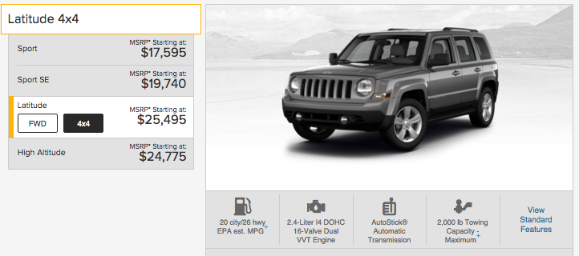
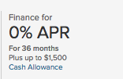 | 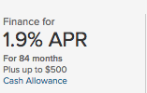 | Note: For this activity, assume Molly’s going to pay the exact MSRP of $25,495. This is most likely NOT true, but we’ll use it for simplicity.

Part I: 0% APR sounds PERFECT!
Answer the following questions using the details from the 0% APR offer above.

- Molly has a $2500 down payment saved for this purchase. Molly assumes the $1500 Cash Allowance will come straight off her total. How much loan does Molly need?

- How much will Molly pay per month to buy this car?

- How much total interest will Molly pay using this plan?

- When Molly adds all of her payments, how much will the car cost her?

Part II: Maybe the 1.9% is more manageable?
Oh, boy! Molly cannot afford the monthly payment using the 0% financing. She opens up Bankrate’s Auto Loan Calculator to see how much she’d pay with the other financing options. Answer the following questions using the calculator and the 1.9% APR offer.

- Molly has a $2500 down payment saved for this purchase. Molly assumes the $500 Cash Allowance will come straight off her total. How much loan does Molly need?

- How much will Molly pay per month to buy this car?

- Click “Show Amortization Table,” which shows how each one of Molly’s payments is being applied to her principal and interest. How much total interest will Molly pay using this plan?

- When Molly adds all of her payments, how much will the car cost her using this plan?

- This amount is SO much more reasonable per month. Molly decides she can contribute $100 more per month. If she does this,
  - How much is her monthly payment?

  - How much total interest will Molly pay?

  - When Molly adds all of her payments, how much will the car cost her?

Part III: Reading the Fine Print
Before she heads into the dealership, Molly notices, in small blue print, “View Disclosure” under the financing deal. When she clicks, she finds the following:

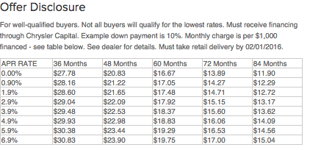
Seeing that the offer is good for a limited time only, she rushes into her local Jeep dealership. She’s confident she’s a “well-qualified buyer” because she’s got a good job and, since graduating from college 1.5 years ago, has never fallen behind with any of her bills. Molly picks out a car, sits down at the financing desk, and hears the following:
Well, we ran your credit history. You’ve got a really thin file -- just a year’s worth of student loan payments. The best deal we can offer you is 6.6% for 60 months. A little more bad news -- the cash allowance is also based on credit history, so you don’t qualify for $500. That said, you’re excited about a Jeep, and I want to see you driving one, so I can do $400 for you!

- Molly still has a $2500 down payment. How much loan does Molly need?

- How much will Molly pay per month to buy this car?

- Click “Show Amortization Table,” which shows how each one of Molly’s payments is being applied to her principal and interest. How much total interest will Molly pay using this plan?

- When Molly adds all of her payments, how much will the car cost her using this plan?

Part IV: In Summary
- What valuable lessons did Molly learn about auto financing?

- Molly desperately wants a Jeep Patriot. What suggestions do you have for making her dream become reality?

